Meshtastic LoRa Room Server
Final Project Report
INFO4 - Polytech Grenoble
Academic year 2025-2026
Authors | TAWFIK Adam  UNAY Arhan
Supervisor | Francois LETELLIER
Project start | January 2026
Date | March 2026

This report summarizes the design, implementation, validation, and project management
of a Room Server built on top of the Meshtastic LoRa mesh network.

Abstract
This project focuses on the design and implementation of a Room Server for the Meshtastic LoRa mesh network. The system runs on a Raspberry Pi 3B connected to a Seeed Studio Wio-E5 Mini radio module and provides an application layer able to create rooms, store messages, and return concise replies adapted to LoRa constraints. Users interact with the server through text commands such as /room create, /room post, and /room read. The project addresses several technical challenges: persistent storage, low-bandwidth communication, limited packet payload, potential packet loss, and robustness after unexpected power loss. To answer these constraints, we selected a modular Python architecture, an SQLite database for persistent local storage, a private Meshtastic channel for isolated tests, and a systemd service to automatically restart the server on boot or after failure. The report presents the project context, requirements, work breakdown structure, technical choices, implementation details, risk management, validation strategy, and lessons learned during development.

Keywords: LoRa, Meshtastic, Raspberry Pi, SQLite, embedded systems, low-bandwidth networking, project management.

Table of Contents
Abstract 2
Table of Contents 3
1. Introduction 5
2. Project Context, Needs, and Objectives 5
2.1 Context and identified need 5
2.2 Main objectives and expected deliverables 6
2.3 Functional perimeter 6
3. Project Management Approach 7
3.1 Development method 7
3.2 Roles and collaborative tools 7
3.3 Stakeholder analysis 7
3.4 SWOT summary 8
4. Work Breakdown Structure and Planning 9
4.1 Work breakdown structure (WBS) 9
4.2 Planned and actual timeline 9
4.3 Time and cost overview 10
5. Quality Criteria, Risks, and Decision Trade-offs 11
5.1 Quality criteria 11
5.2 Cost-delay-quality triangle 11
5.3 Risk analysis and mitigation 11
6. Technical Architecture and Design Choices 13
6.1 Hardware and software stack 13
6.2 Logical architecture 14
6.3 Main modules 15
6.4 Task Allocation and Main Contributions 17
6.5 Lines of Code and Implementation Volume 17
6.6 Persistence strategy 18
7. Implementation Details 19
7.1 Command model 19
7.2 Sequence of a message posting operation 19
7.3 LoRa-specific optimizations 19
7.4 Deployment and operational robustness 20
8. Tests, Validation, and Observed Results 21
8.1 Validation strategy 21
8.2 Main test scenarios 21
8.3 Limits of the validation campaign 21
8.4 What was effectively demonstrated 22
9. Impacts, Lessons Learned, and Future Work 23
9.1 Project impacts 23
9.2 Lessons learned 23
9.3 Possible extensions 23
10. Conclusion 24
Bibliography and Sources 25
Appendices 26
Appendix A - Example command set 26
Appendix B - Main deliverables 26

1. Introduction
LoRa networks are designed for long-range communication with low power consumption and limited data throughput. They are particularly relevant for Internet of Things applications deployed in environments where conventional network infrastructure is unavailable, unreliable, or too costly. Meshtastic builds a decentralized mesh layer on top of LoRa and enables text-based communication between nodes without relying on the Internet.
However, the default Meshtastic workflow mainly relies on broadcast messaging. In practice, this means that messages are shared across the network without native support for persistent chat rooms, structured message history, or advanced conversation organization. The engineering challenge of this project was therefore to create a specialized node, called a Room Server, able to add these missing features while preserving compatibility with the existing Meshtastic ecosystem.
The report is organized in two complementary dimensions. The first one documents the technical product: hardware setup, software architecture, command processing, persistence strategy, deployment, and validation. The second one documents how the project was managed: work breakdown structure, planning, team organization, quality criteria, risks, and lessons learned.

2. Project Context, Needs, and Objectives

2.1 Context and identified need
The subject provided by the supervisor required the design of a Meshtastic Room Server able to receive commands through LoRa messages, manage chat rooms, and keep message history persistent after reboot. The server had to be built with portable software, off-the-shelf hardware, and a robust storage strategy suitable for an embedded environment. The Room Server was expected to operate above Meshtastic, without modifying the Meshtastic protocol itself.
The need can be summarized as follows: users should be able to organize exchanges into logical rooms, retrieve message history on demand, and rely on the service even after abrupt shutdown. This need is particularly meaningful in low-infrastructure or emergency communication contexts, where a compact and autonomous messaging service may bring practical value.

2.2 Main objectives and expected deliverables
- Provide a command-based interface: room creation, room listing, message posting, and room reading.
- Store rooms and messages persistently on the server side.
- Deploy the application on a Raspberry Pi connected to a Meshtastic-compatible LoRa radio.
- Demonstrate restart robustness after server reboot or USB disconnection.
- Produce technical documentation, project management documentation, and a final report.

2.3 Functional perimeter
Function | Description | Status in project scope
Room creation | Create a room identified by a unique name. | Implemented
Room listing | Return the existing rooms stored on the server. | Implemented
Message publication | Store a new message inside a selected room. | Implemented
History reading | Read the latest N messages from a room. | Implemented with limits
Help command | Provide a concise command summary. | Implemented
Persistence after reboot | Keep rooms and messages after restart. | Implemented
User rights / access control | Advanced permissions and restricted rooms. | Not implemented
The table above distinguishes the validated core features from optional extensions. Advanced administration, user rights, or cross-server synchronization were considered outside the minimum perimeter and are discussed later as possible extensions.

3. Project Management Approach

3.1 Development method
The project followed a lightweight iterative approach close to agile development. Instead of building the whole system in one pass, we advanced through short weekly iterations driven by technical milestones: hardware acquisition, database initialization, command parsing, LoRa integration, robustness improvements, and final documentation. Each week ended with a progress report describing completed tasks, issues, and next objectives.

3.2 Roles and collaborative tools
Area | Main contribution | Tools used
Backend and architecture | Command parser, business logic, data model, architecture documentation. | Python, Markdown, Git
Hardware and system integration | Raspberry Pi setup, USB/serial communication, systemd service, field tests. | Linux, Meshtastic CLI, journalctl
Documentation and reporting | Weekly reports, meeting report, final report, planning and slides. | LibreOffice / Word, Git, PDF
The repository, technical notes, weekly progress reports, and meeting report formed the shared project memory. During the temporary GitLab outage, a private repository was used as an intermediate solution before migration to the school environment.

3.3 Stakeholder analysis
Stakeholder | Role | Expectation | Impact on project
Students | Design and implement the solution | Deliver a working demonstrator and documentation | Direct execution
Supervisor | Validate direction and evaluate results | Technical coherence and project management discipline | High
FabLab / hardware providers | Provide Raspberry Pi and LoRa modules | Availability of working hardware | Medium
Future users / evaluators | Test the demonstrator | Simple commands, reliable replies, persistent history | Medium

3.4 SWOT summary
Strengths  Modular Python architecture; simple command model; persistent storage with SQLite; realistic embedded deployment. | Weaknesses  Limited radio bandwidth; dependency on physical hardware; restricted time for extensive performance benchmarking.
Opportunities  Use in emergency or infrastructure-limited communication scenarios; future web interface or rights management. | Threats  Packet loss, USB disconnection, power instability, and environmental variability during radio tests.

4. Work Breakdown Structure and Planning

4.1 Work breakdown structure (WBS)
WBS ID | Task | Main output | Notes
1 | Project framing and requirement analysis | Problem statement, milestones | Based on subject sheet and kickoff discussions
2 | Hardware preparation | Raspberry Pi and Wio-E5 available | Included power supply troubleshooting
3 | Persistence layer | SQLite schema and storage class | rooms and messages tables
4 | Command processing | parser.py and room_manager.py | Business logic for /room commands
5 | Communication layer | meshtastic_comm_hw.py and client.py | Real hardware communication and client simulator
6 | Robustness layer | logger.py, reset_db.py, systemd service | Restart, monitoring, recovery
7 | Validation and documentation | Weekly reports, tests, final report, flyer | Project management traceability

4.2 Planned and actual timeline
The project was organized as an incremental sequence of milestones. The initial planning was refined each week through progress reports. The figure below summarizes the timeline used to monitor the project.
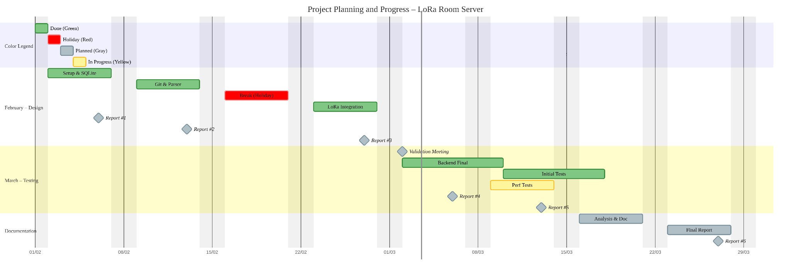
Figure 1 - Project planning and timeline used for weekly monitoring.
The timeline highlights a progression from problem analysis and database initialization toward hardware integration, robustness work, and final documentation. The main gap between forecast and reality came from hardware-related issues, especially the Raspberry Pi power supply and the need to stabilize radio communication before large-scale testing.

4.3 Time and cost overview
Resource | Status | Comment
Hardware budget | Provided by laboratory | Raspberry Pi 3B and Wio-E5 modules were supplied for the project.
Software budget | No additional license cost | Python, SQLite, Meshtastic CLI, and Linux tools were open or already available.
Human workload | Tracked through weekly progression | Work volume was mainly measured through milestones, implementation tasks, and reporting.
A precise hour-by-hour timesheet was not maintained, but the project did include continuous weekly reporting. This means that the human cost can be described qualitatively through the documented iterations, the number of implemented modules, and the validation activities.

5. Quality Criteria, Risks, and Decision Trade-offs

5.1 Quality criteria
Criterion | Reason | How it was addressed
Modularity | Facilitates debugging and maintenance | Separate modules for parsing, room management, communication, database, and logging.
Persistence integrity | Server state must survive restart | SQLite chosen instead of a flat file because it supports transactions.
Operational robustness | Embedded hardware can fail or disconnect | systemd auto-restart and hardware path monitoring.
Readable user interaction | LoRa replies must remain short and clear | Concise command syntax, direct acknowledgements, and message chunking.
Traceability | Project decisions must be explainable | Weekly reports, meeting report, and technical architecture note.

5.2 Cost-delay-quality triangle
The project constantly balanced three priorities. The first one was quality, because persistence and reboot robustness were mandatory. The second one was schedule, as the project had to reach a demonstrable state within the semester. The third one was cost, which remained limited because the main hardware was provided by the laboratory. This context justified several decisions: focusing on a reliable local SQLite storage rather than a more complex distributed database, using simple text commands instead of a richer but heavier interface, and prioritizing real hardware validation over optional feature expansion.

5.3 Risk analysis and mitigation
Risk | Potential impact | Mitigation | Observed status
Insufficient Raspberry Pi power supply | Server unavailable | Replace the adapter and validate boot stability | Observed and solved
LoRa payload size limitations | Replies truncated or lost | Reduce payload size and split longer content | Observed and mitigated
USB radio disconnection | Process hang or no communication | Monitor hardware presence and use systemd restart | Observed and mitigated
Public channel interference | Noise from external users | Configure a private channel with a dedicated PSK | Observed and mitigated
Limited time for benchmarking | Incomplete quantitative performance analysis | Prioritize demonstrator validity and core tests | Partially accepted

6. Technical Architecture and Design Choices

6.1 Hardware and software stack
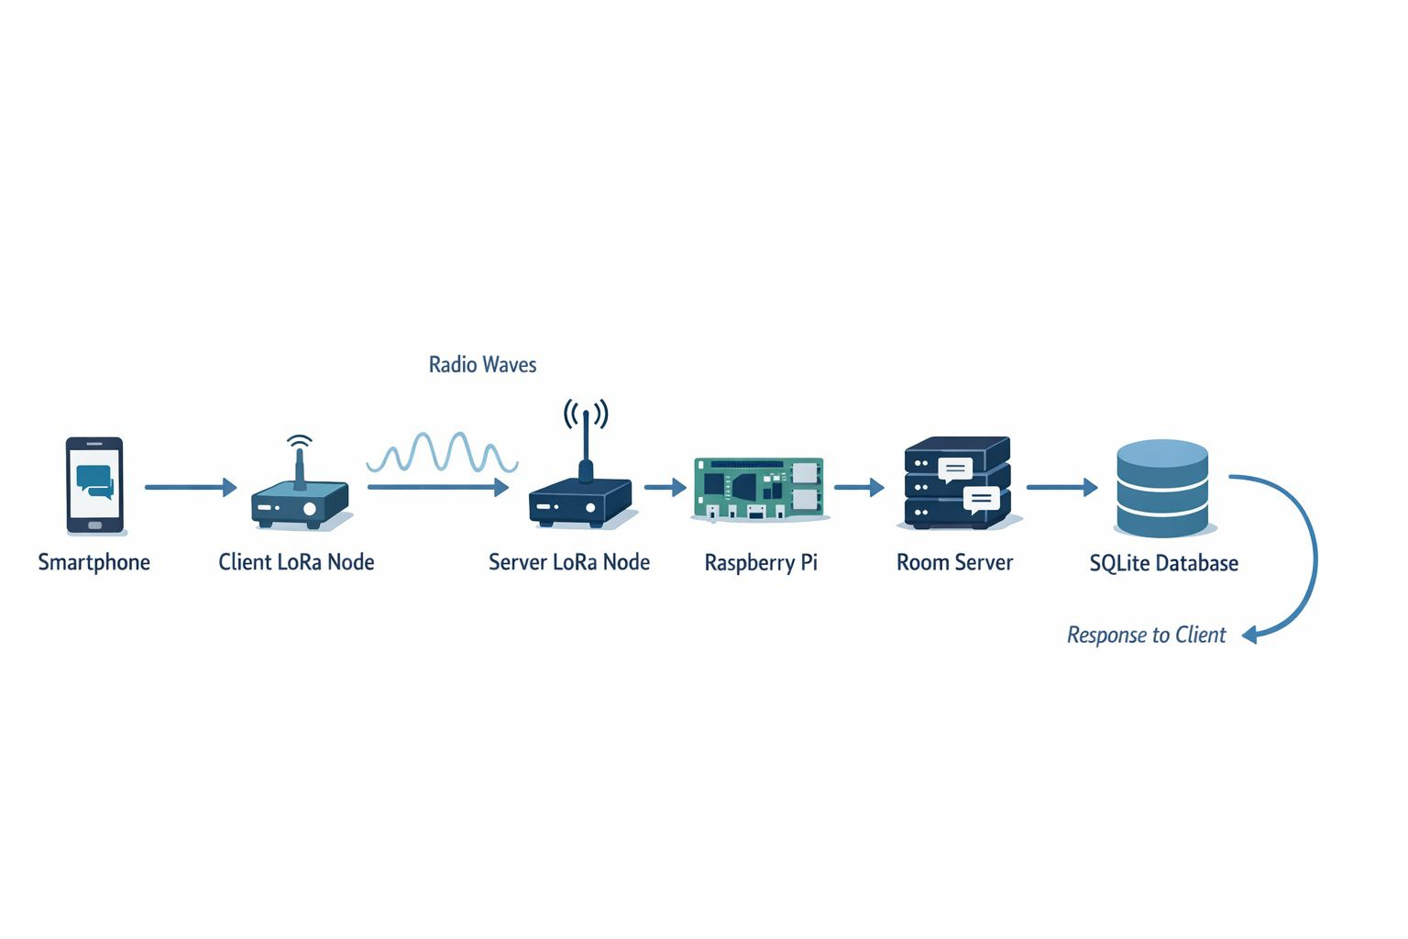
Figure 2 - End-to-end system architecture from the smartphone client to the Room Server and SQLite database.
This architecture diagram summarizes the complete data path of the demonstrator. A user sends a command from the smartphone through a client LoRa node. The packet crosses the LoRa link toward the server node connected to the Raspberry Pi, where the Room Server processes the request and stores or retrieves data from the SQLite database before sending a response back to the client.
Layer | Selection
Server hardware | Raspberry Pi 3B
Radio module | Seeed Studio Wio-E5 Mini
Operating system | Raspberry Pi OS / Linux
Main language | Python 3
Persistence | SQLite
Communication framework | Meshtastic Python tooling and serial interface

6.2 Logical architecture
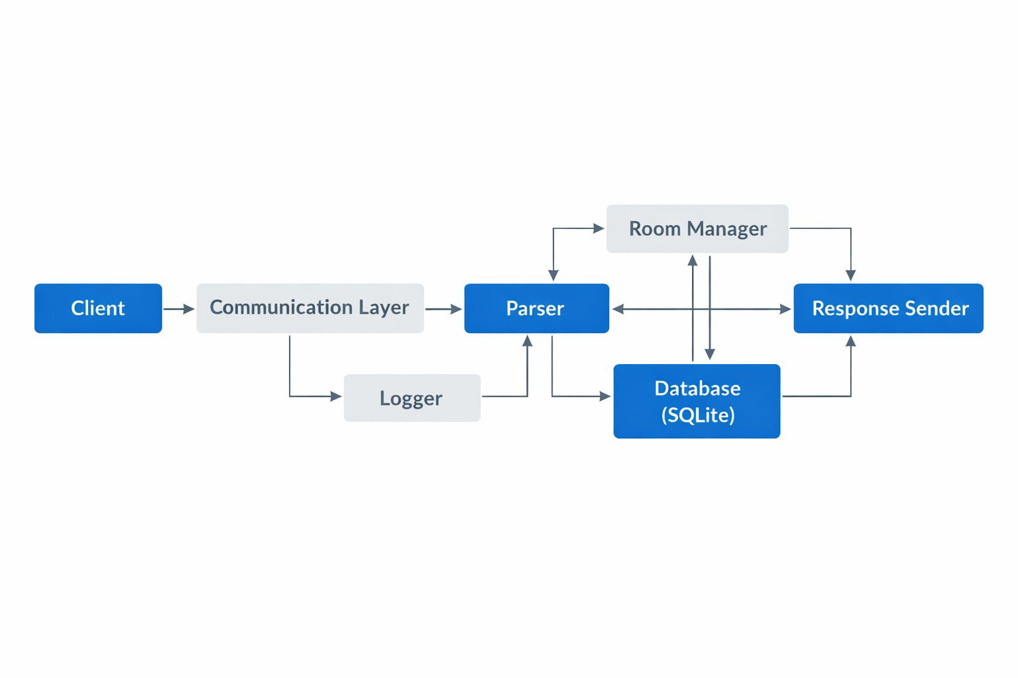
Figure 3 - Software architecture showing the interaction between the communication layer, parser, Room Manager, response sender, logger, and SQLite database.
The software architecture deliberately separates transport concerns from business logic and persistence. The communication module receives packets from the Wio-E5 radio, the parser identifies valid commands, the RoomManager applies the corresponding business rules, and the database module stores or retrieves persistent data. Additional operational modules support logging, reset, and restart supervision.
The class diagram complements the previous logical view by detailing the main software classes used in the implementation. It highlights the central role of RoomManager, which coordinates command handling, storage access, and response production. The diagram also shows the interaction between TransportHardware, IncomingMessage, OutgoingMessage, CommandParser, StorageSQLite, and the global logger. This view is useful to understand how responsibilities are distributed in the code and how modularity was preserved throughout the implementation.
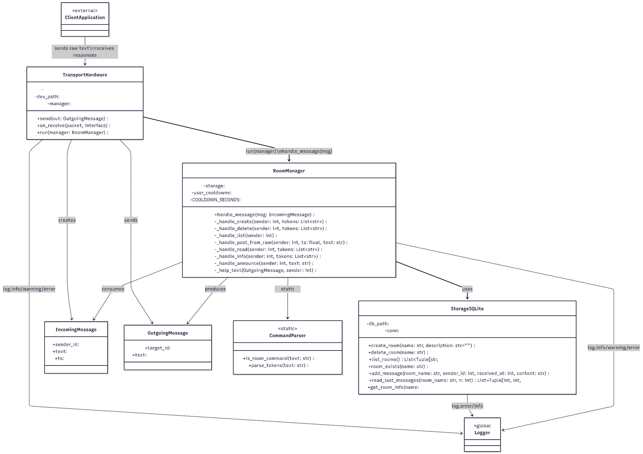
Figure 4 - UML class diagram of the main software entities and their relationships.

6.3 Main modules

File/Module | Main Role | Technical Descroption
main.py | Entry Point (Orchestrator) | This is the file executed to start the server. It initializes the database, theRoomManager, and connects the hardware.
parser.py | Syntax Parser (Translator) | Parses /room commands, extracts tokens, and helps the server distinguish actions and arguments before execution.
room_manager.py | Business Logic (Brain) | Central module of the server. It processes incoming commands, manages rooms, applies anti-spam protection, formats long replies, and coordinates all interactions with the SQLite storage layer.
database.py | Data-Management (Storage) | Manages the SQLite connection. It creates the tables (rooms, messages) and contains functions to insert or read data (CRUD).
meshtastic_comm_hw.py | Hardware Interface (Real Driver) | This is the Wio-E5 "driver". It listens to the USB port (/dev/ttyUSB0), captures incoming LoRa signals, and sends responses.
meshtastic_comm.py | Simulation Interface (Mock) | Simulates the LoRa interface via the console. Allows testing the entire server logic without connected hardware, using the keyboard as input and screen as output.
client.py | Client Simulator (Tester) computer | The script used on the test computer. It allows sending messages to the server via a second LoRa module, simulating a real user.
logger.py | Logging (Tracker) | Provides logging support across the application for debugging, monitoring, warnings, and error tracking.
reset_db.py | Maintenance Tool (Cleaner) | A small utility script to cleanly delete the.db file and reset the database to zero in case of problems.

6.4 Task Allocation and Main Contributions
The implementation work was distributed between the two team members according to the project needs and the progression of the development phases. The following table summarizes the main files and responsibilities handled by each contributor.

Team Member | Main Contributions | Main Files
Adam TAWFIK | Parsing logic, hardware communication, client-side interaction, main application orchestration | parser.py, meshtastic_comm_hw.py, client.py, main.py
Arhan UNAY | Database layer, room management logic, simulation interface, logging, maintenance utilities | database.py, room_manager.py, meshtastic_comm.py, logger.py, reset_db.py

6.5 Lines of Code and Implementation Volume
To provide a measurable overview of the development effort, we estimated the size of the main Python modules produced during the project. The following table summarizes the implementation volume for each file.

File | Total Lines | Approx. Code Lines
main.py | 32 | 13
database.py | 159 | 135
room_manager.py | 292 | 193
parser.py | 38 | 26
meshtastic_comm_hw.py | 162 | 109
meshtastic_comm.py | 64 | 49
client.py | 107 | 64
reset_db.py | 59 | 38
logger.py | 32 | 17
Total | 945 | 644

Overall, the project represents approximately 945 total lines and about 644 effective lines of code across the main implementation files. This gives a concrete indication of the software development effort carried out during the project.

6.6 Persistence strategy
SQLite was selected as the storage engine instead of a flat JSON file. The main reason is reliability: SQLite supports atomic transactions and is more resilient when a write operation is interrupted by a crash or power cut. This directly supports the project requirement that rooms and messages must remain consistent after an abrupt shutdown.
The core schema includes a rooms table and a messages table. The rooms table stores room identity and metadata, while the messages table stores the room reference, sender node identifier, timestamp, and message content. This relational split is simple enough for embedded use and sufficient for the demonstrator scope.

7. Implementation Details

7.1 Command model
The command interface was intentionally kept simple. Commands start with the /room prefix and are followed by a subcommand and the required arguments. Examples of supported commands include /room create, /room list, /room post, and /room read. This choice reduces user-side complexity and keeps the parser lightweight.

7.2 Sequence of a message posting operation
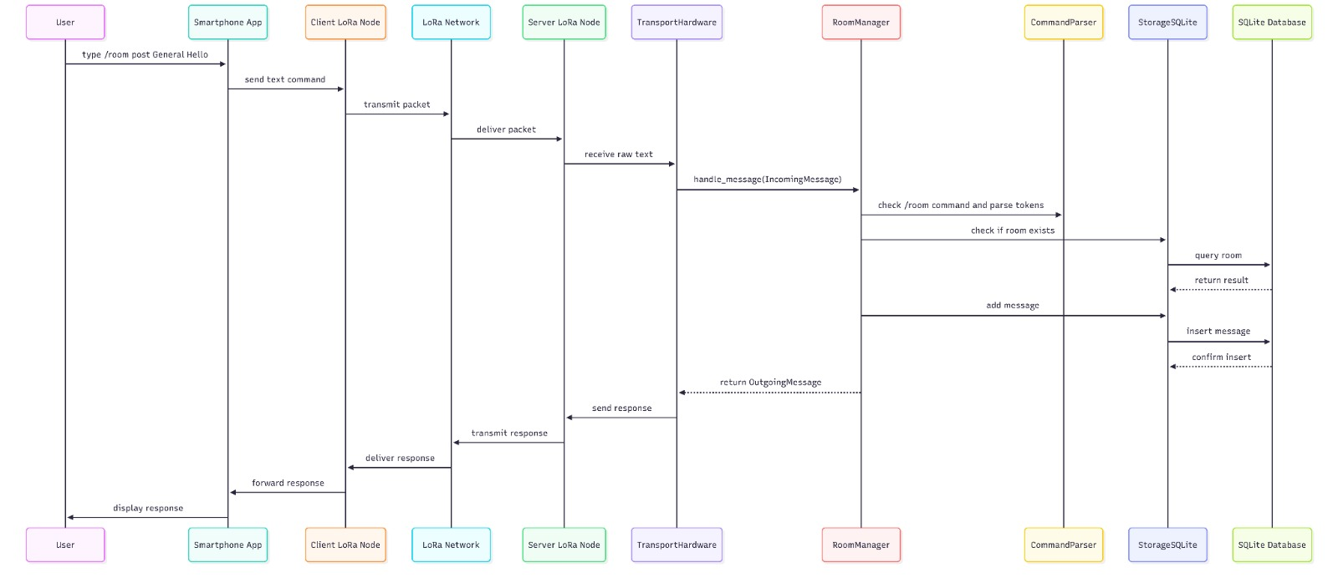
Figure 5 - Detailed sequence diagram of a /room post command from the user interface to database insertion and response transmission.
The detailed sequence diagram shows the main data path for message posting. The packet first reaches the communication layer, then the parser verifies the syntax. The RoomManager checks the room state and triggers the database insertion. Once the transaction succeeds, a concise acknowledgement is built and returned to the requester through the LoRa communication chain.

7.3 LoRa-specific optimizations
- Replies are kept concise to fit within LoRa payload limitations and to reduce time-on-air.
- Room history reading is intentionally limited so that the network is not saturated by long responses.
- Longer content is segmented into shorter chunks; this reduces the probability of loss and improves readability on constrained devices.
- Administrative replies are sent as private messages when appropriate to avoid cluttering the public channel.
These optimizations are not cosmetic. They are directly linked to the radio constraints of LoRa: low throughput, limited payload size, and the risk of packet collision or loss when messages become too long.

7.4 Deployment and operational robustness
After local development, the software suite was deployed onto the Raspberry Pi. A systemd service was configured so that the application starts automatically at boot and restarts after failure. This approach improves availability and aligns with the requirement that the Room Server must remain operational even after abrupt events.
A dedicated private channel was also configured to isolate the demonstrator from unrelated public traffic. This reduced interference during experiments and improved the stability of the validation sessions.

8. Tests, Validation, and Observed Results

8.1 Validation strategy
Validation was carried out progressively, first in a local mock environment and then on real hardware. The objective was not only to verify nominal behavior but also to confirm that the system remained coherent after reboot, database reset, USB disconnection, and background execution.

8.2 Main test scenarios
Scenario | Goal | Expected result | Observed status
Create room | Check basic command execution | Server acknowledges room creation | Validated
Post message | Check storage path | Message stored in the selected room | Validated
Read history | Check retrieval and formatting | Recent messages returned in concise form | Validated
Restart persistence | Check data survival after reboot | Rooms and messages remain available | Validated
USB disconnection | Check recovery strategy | Server exits cleanly and restarts under systemd | Validated
Private channel configuration | Check isolation from external traffic | Only correctly configured nodes interact | Validated

8.3 Limits of the validation campaign
The validation campaign confirmed the functional objectives of the demonstrator, but it remained mostly qualitative rather than statistically exhaustive. For example, we did not produce a large dataset of latency measurements under many simultaneous clients. This limitation is mainly due to time constraints and the practical complexity of repeating controlled radio experiments.

8.4 What was effectively demonstrated
Despite these limits, the project reached a meaningful maturity level. The team demonstrated that a Raspberry Pi-based node can extend Meshtastic with persistent rooms, command-based interaction, and controlled recovery after failure. This validates the core engineering idea behind the Room Server.

9. Impacts, Lessons Learned, and Future Work

9.1 Project impacts
From a technical point of view, the project demonstrates a practical use case for LoRa mesh networking beyond plain broadcast messaging. By adding a room-oriented application layer, the system makes the network more usable for structured exchanges. The meeting report also emphasized the potential relevance of such a service in isolated zones or emergency contexts where conventional telecommunications may be unavailable.

9.2 Lessons learned
- Embedded projects are strongly influenced by hardware details such as power supply quality and serial device behavior.
- Low-bandwidth systems require concise protocols and disciplined message design.
- A modest but reliable architecture is often preferable to a feature-rich but fragile implementation.
- Continuous reporting makes it easier to explain design choices and justify trade-offs at the end of the project.

9.3 Possible extensions
- User rights and administration roles for private or restricted rooms.
- Local web interface hosted on the Raspberry Pi.
- Multiple Room Server synchronization or replication.
- Usage statistics and monitoring dashboard.
- More quantitative performance measurements under controlled radio conditions.

10. Conclusion
This project achieved its main goal: designing and implementing a Meshtastic Room Server able to manage rooms, store message history, and keep its state after restart. The resulting demonstrator combines a Raspberry Pi, a Wio-E5 LoRa module, a modular Python code base, and an SQLite database into a coherent embedded communication service.
The work also illustrates an important engineering principle: in constrained environments, system value does not come from complexity but from choosing the right compromises. By focusing on persistence, robustness, concise communication, and deployment realism, the project produced a result that is both technically relevant and demonstrable.

Bibliography and Sources
- Project brief: Meshtastic LoRa Room Server subject sheet.
- Technical architecture note and implementation guide produced during the project.
- Weekly progress reports and client meeting report.
- Meshtastic tooling and command-line usage observed during deployment and testing.
- Project management writing guidelines provided by the supervisor.
The references above correspond to the internal project documents and tools that directly informed this report. Additional external technical documentation may be added later if a formal bibliography in APA style is required for the final submission package.

Appendices

Appendix A - Example command set
/room create ProjectAlpha
/room list
/room post ProjectAlpha Hello Team
/room read ProjectAlpha 5

Appendix B - Main deliverables
- Python source code for the Room Server and test client.
- Technical architecture note.
- Weekly progress reports.
- Mid-project client meeting report.
- Flyer, slides, and final report.

